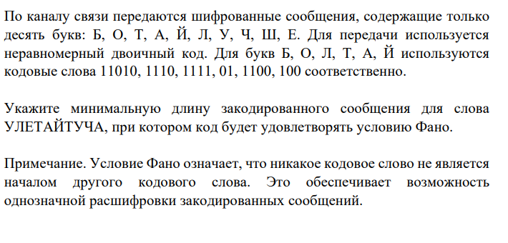

|  |  |  |  |  |  |  |  |  |  |
| --- | --- | --- | --- | --- | --- | --- | --- | --- | --- |
| Б | О | Т | А | Й | Л | У | Ч | Ш | Е. |
| 11010 | 1110 | 01 | 1100 | 100 | 1111 |  |  |  |  |
|  |  | 2 | 2 | 1 | 1 | 2 | 1 |  | 1 |
|  |  | 4 | 8 | 3 | 4 | 4 | 3 |  | 5 |
| Ответ 31 |  |  |  |  |  |  |  |  |  |

